Template for Japan-Korea Joint Symposium
Taro YAMADA¹, Hanako SATO²
¹Graduate School of Sample University, Tokyo, Japan
²Sample University, Tokyo, Japan
sample@japan-u.ac.jp

Abstract
The purpose of this study is to examine the differences in the characteristics between the dominant hand and non-dominant in the hand operation which needs adjustment control. In this study, we compared the performance of the force adjustment task between with dominant hand and the non-dominant hand and re-examined the product design. We also examined the mental workload between the above two conditions, that are the tasks with the dominant hand and with the non-dominant hand. As a result, it was cleared that both the right-handed subject and the strong-left-handed subject could adjust with less muscle strength in case they used the dominant hand. And it was also cleared that they output more force than necessary in case they used the non-dominant hand. Further, it could be found the remarkable differences in the result of performance, EMG, and mental workload (NASA-TLX) between with the dominant hand and with the non-dominant hand no matter whether the subject was right-handed or left-handed. On the other hand, in case the subject was the weak-left-handed, it could not be found the distinguished differences in the result of performance, EMG, and mental workload (NASA-TLX) between with the dominant hand and with the non-dominant hand.

Keywords: dominant hand, left-handed, weak left-handed, force adjustment

1.Introduction
90% of the world’s people are Right-handed. Therefore, our personal belongings such as scissors, ticket gates, cameras are designed to be used with right hand. Recently, left-handed products have been developed so that remaining 10% of the left-handed people can use comfortably. However, left-handed people are reported to have had no significant difference in their work non-dominant and dominant hands [1]. This is also reported in other studies [2][3]. A possible factor is that left-handed users are surrounded by products made for right-handed. In this research, we investigated differences in handedness and the characteristics of force adjustment that are the basis of left-handed product development.

2.Experiment 1: performance
2-1. outline of experiment
Subject: 33 (male: female = 20 : 13) . Right-handed : Left-handed = 17 : 16. Age = 20.4±1.01. Procedure: The handedness was judged by LQ test [4] to calculate the strength of the handedness and the degree of handedness. After each task was completed, mental workload was measured using the Japanese version of NASA-TLX[5] Require time=average 30 min / person. Tools: We chose scissors (ASKUL: PLUS scissors fit curve SC-175) that are common household items and relatively large in left-handed products. Tasks: As an experimental task, using the above-mentioned right-handed scissors, the designed shape (Star shape: R 150mm) printed on A4 paper was continuously cut 10 times using a dominant hand and non-dominant hand. The difference in time required for each operation and the number of mistakes was compared.

2-2. experiment 1 result
The result of the working time showed in Figure1. Right-handed took twice as long to work with the non-dominant hand. On the other hand, left-handed people did not see strong left-right differences. The left-handed experiment subjects had strong left-handed and weak left-handed, who routinely use non-dominant hand in order to receive corrections in the past and adjust to living environment. Therefore, we defined them as “WL: weak left-handed” and the left handedness with strong left as “SL: strong left-handed”. A comparison of right-handed, SL and WL mental work load in the experiment showed in Figure 2. It shows right-handed people feel a heavy burden on using non-dominant hands. On the other hand, it was found that the left-handed, especially the WL, did not feel the load relatively.
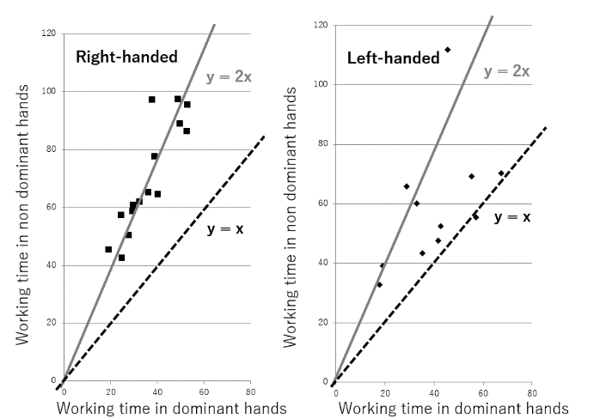
Figure1 Working time ratio of dominant and
non-dominant hands

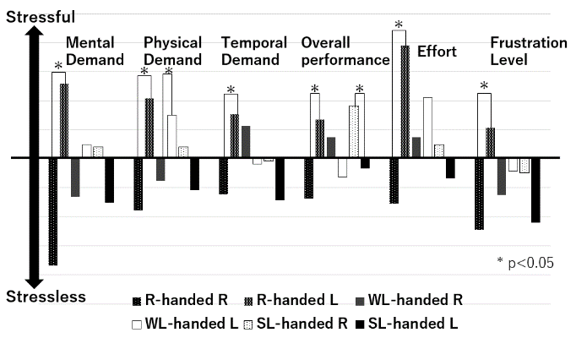
Figure2 Comparison of mental workload results divided by strength of dominant hand.
3. Experiment 2: force adjustment
3-1. outline of experiment
Subjects: 7 (male: female = 4: 3). Right-handed : Left-handed = 3 : 4. Age20.7±0.45. Procedure: The handedness was judged by LQ test to calculate the strength of the handedness and the degree of handedness. Worked on the task of force adjustment with the dominant and non-dominant hands. Six electrodes were attached to measure the muscle activity the experiment subjects. The muscles used for measurement are PL: palmaris longus and EDC: extensor digitorum communis [6]. Equipment: A simple measurement surface electromyography (MWatch) was used to collect muscle activity. We used a cylinder (R 15mm, H 50mm) for the thing to hold. Tasks: Subjects were instructed to develop a constant strength for 5 seconds. The results obtained 5times continuously at interval of 5 seconds. At this time, a waveform of the development status of one’s own muscle was presented by visual information.

3-2. experiment 2 result
The results showed in Figure 3. Right-handed subjects are able to adjust with less strength when adjusting their strength with the dominant hand. However, when the work with a non-dominant hand, the muscles are active more than necessary to adjust muscle strength. It means the force adjustment is unfamiliar because the standard deviation of the values of muscle activity is larger for the non-dominant hand than for the dominant hand. The left-handed showed differences in characteristics between the SL and the WL as in the experiment described in the previous section. The SL subjects have a greater non-dominant muscle activity than the dominant hand, and significant difference in standard deviation. This is the same as result of right-handed. On the other hand, in the group of WL, observed that the muscle activity was close to left-handed but no significant difference was found. From this results, it confirmed that the WL subjects was relatively able to force adjust as expect.

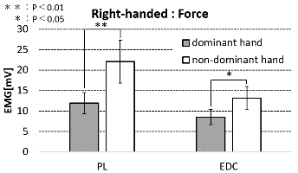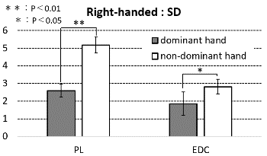
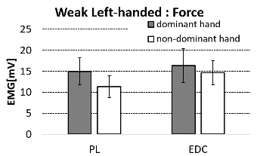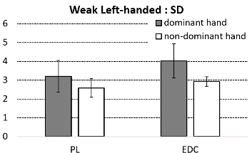
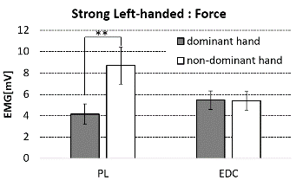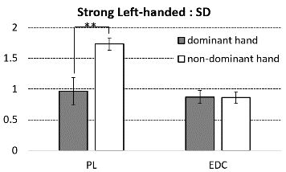
Figure3. Results of the force adjustment
right-handed, WL and SL
4.Conclusion
In this study, we surveyed and analyzed non-dominant work, performance and force adjustment. As a result, right-handed subjects are unfamiliar with performance and force adjustment, and operation with non-dominant hand required a lot of working time. In addition, the results collected by electromyography that the force adjustment more than necessary and did not work well. It is clear from the result of NASA-TLX data that using non-dominant hands also feels a strong mental burden. Left-handed subjects can divide into two groups as experiment 1. SL subjects can not work well with non-dominant hand and force adjustment like right-handed. However, although WL in the LQ test showed the result likely a left-handed, but there was no significant difference between left and right operation and force adjustment. Also in the result of NASA-TLX, the result is that amount of load is small and used to the situation of using non-dominant hand.

5.Summary
In this study, we compared the performance of power adjustment and work with non-dominant hand according to the classification of dominant hand and the distinction between the dominant hand and its strength. As a result, it turned out that work with both right-handed and left-handed non-dominant hands requires much time and power adjustment is more than necessary. We will collect information on differences between dominants and their strength as information necessary for the design stage of products that are expected to be operated by non-handed persons.

Contact
More information is available at:
sampleauthor@japan-u.ac.jp

References
[1]Hongson SHIN, Shigeru HAGA: Ergonomic Appraisal of everyday things for left-handed people.-EMG performance, Subjective measures-, Japanese Journal of Ergonomics, Vol37, Supplement, pp440-pp441,1970
[2]M. Mani et al: Studies on laterality in relation to individual work ability, Japanese Journal of Ergonomics, Vol.7, No.2 pp99-105, 1971
[3] Rina TAKAHASHI, Atsuo MURATA: Difference of Error Characteristics between Preferred and Non-preferred Hands in Touch-panel Operation-Comparison between Young and Older Adults-, Neuropsychologia, Vol.9, pp.271-276, 1995
[4] Oldfield, R.C.: The assessment and analysis of handedness, The Edinburgh Inventory, 1971
[5]Shigeru HAGA, Naoki MIZUKAMI: Japanese version of NASA Task Load Index: Sensitivity of its workload score to difficulty of three different laboratory tasks, Japanese Journal of Ergonomics, Vol.32, No.2, pp71-pp79, 1996
[6] Hiraku KITAMOTO: A Study on the muscle control of right and left hand, Japanese Journal of Ergonomics, Vol.35, No.5, pp259-pp263.1979

